**CREATE A PASSWORD GENERATOR USING PYTHON**

**AIM:**

TO CREATE A PASSWORD GENERATOR USING PYTHON

**OBJECTIVE**:

ALPHABET

NUMBERS

SYMBOLS

**CODE:**

import string

import random

# Getting password length

length = int(input("Enter password length: "))

print('''Choose character set for password from these :

1. Digits

2. Letters

3. Special characters

4. Exit''')

characterList = ""

# Getting character set for passworD

while(True):

choice = int(input("Pick a number "))

if(choice == 1):

# Adding letters to possible characters

characterList += string.ascii_letters

elif(choice == 2):

# Adding digits to possible characters

characterList += string.digits

elif(choice == 3):

# Adding special characters to possible

# characters

characterList += string.punctuation

elif(choice == 4):

break

else:

print("Please pick a valid option!")

password = []

for i in range(length):

# Picking a random character from our

# character list

randomchar = random.choice(characterList)

# appending a random character to password

password.append(randomchar)

# printing password as a string

print("The random password is " + "".join(password))

**OUTPUT:**

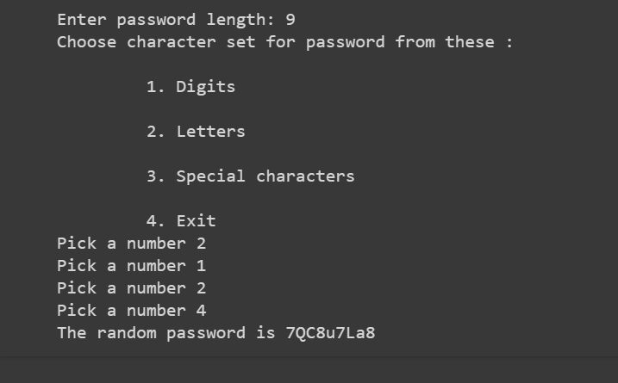

**RESULT:**

PASSWORD GENERATOR IS EXECUTED SUCCESSFULLY USING PYTHON